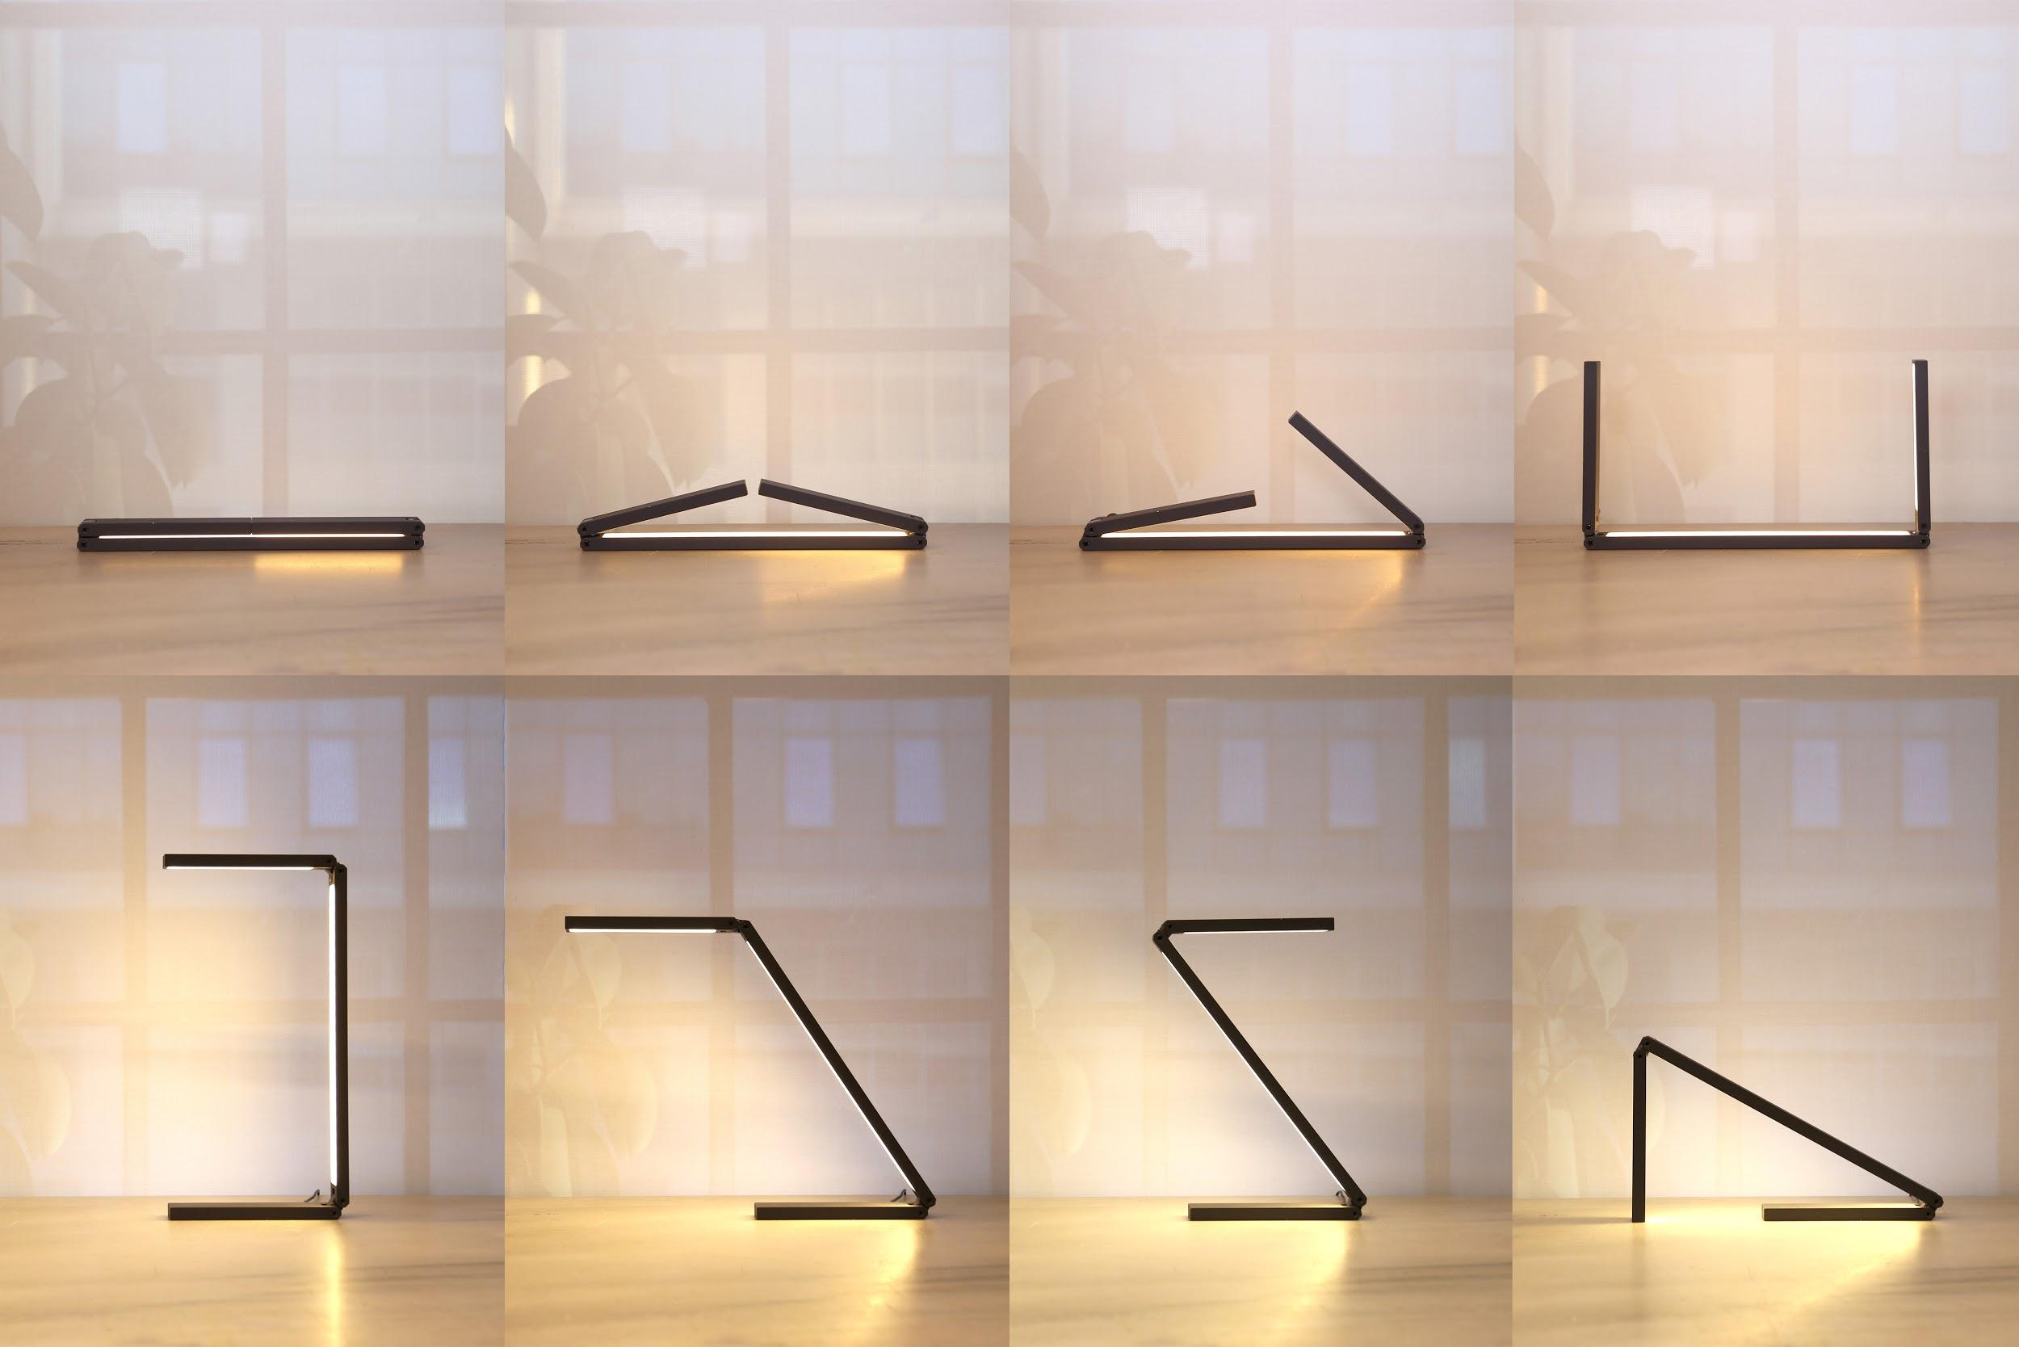

LIMINAL: A minimal adaptable lighting unit

ATÖLYE Labs and Buşra Tunç are excited to announce LIMINAL, a minimal and multifunctional lighting unit that follows innovative design practices. LIMINAL was developed in order to accommodate the demand for flexibility in the modern world, as it can transform itself into numerous variations via its kinetic joints and adjustable modules.

LIMINAL was born out of a collaboration between CNVS, the Istanbul-based furniture brand developed by ATÖLYE Labs, and architect/artist Buşra Tunç. The product was debuted in this year’s Ventura Lambrate in Milan as part of the young designers’ collective Form & Seek. The creators have intended for the product to meet the needs of modern work and education workspaces, in which flexible usage has become an increasing necessity.

Minimal aesthetic of a single line
LIMINAL draws its inspiration from a single line. The lighting unit has a plain form and a compact design, which allows for the variations in usage. Light source is situated in both sides, with a three-scenario switch that enables combinations of use with the flexible kinetic framework. With its foldable body, LIMINAL can be easily packed and doesn’t take too much space.

A design to provide adaptable lighting in a variety of environments
LIMINAL can be folded in different directions, and provides many scenarios via its rotatable joints. Diffuse, high-grade LED lights are placed on two surfaces, with multiple switch outputs. It can fit in different kinds of spaces like home, office or library, and to different surfaces, including desks and walls. Despite its adaptable usage scenarios, LIMINAL blends in with its environment to take on an appearance of invisibility. The products’ aesthetic qualities make strong references to the visual narratives in architecture.
Solid and custom-designed formation
LIMINAL is made out of solid, high-caliber aluminium blocks that are CNC-milled and refined with traditional manufacturing methods such as metal lathe. It includes custom designed, patent-pending, 270 degree rotatable stainless steel joints, IP20 certification as well as durable cable connections.
LIMINAL is based and produced in Istanbul
Partnership with local artisans played a fundamental role during the manufacturing process of LIMINAL, which enabled its rapid iteration and detail-driven development. All of the prototyping process was conducted with artisans in 5 km vicinity of the design studio, including experienced craftsman Yüksel Demirel, which enabled the coupling of deep expertise with user-centered innovation.

How did the idea come about?
The idea was born upon the needs of ATÖLYE, an interaction and creativity platform based in İstanbul. When the team was searching for proper furniture to complement their workspace, they couldn’t find the perfect fit, so they came up with their own solution and developed the furniture brand CNVS. The brand seeks to design dynamic and multifunctional furnitures and accessories for work and learning spaces. LIMINAL was created as a collaboration between ATÖLYE Labs and Buşra Tunç, where Buşra’s concept and design was enhanced by ATÖLYE Labs' transdisciplinary team, which combines skill sets in fields that range from graphics to electronics, from user experience to materials.

This CNVS accessory represents the beginning of more kinetic, small-scale and responsible modular elements, bound to be improved in the future with a dimming function and an adjustable color temperature system.
A crowdfunding campaign is ready to be launched
LIMINAL seeks to be one of the few Turkish design products to be funded through popular crowdfunding platform Kickstarter. LIMINAL will receive all of its funding via a dedicated crowdfunding campaign in November. The team has worked on this project for more than a year, and is looking forward to receive support to bring LIMINAL to life.

Over the next few months, the team will focus on further refining the manufacturing details such as LED production, cabling, embedded PCBs, packaging, switches and chassis production. Overall, they have liaised with all potential candidates and collaborators, and are just waiting for Kickstarter feedback before they come out with final production plan.

Notes to Editors:

About ATÖLYE Labs
ATÖLYE Labs is an Istanbul-based transdisciplinary design, technology and innovation studio that designs interfaces, objects and spaces. ATÖLYE Labs seeks interdisciplinary collaboration, design entrepreneurship and long-term value creation.
ATÖLYE Labs designs social objects at all scales. As curious generalists, the team wants to tackle the challenge at the appropriate scale. What matters to ATÖLYE Labs are the common goal: to bring all stakeholders together, to redefine design at all contexts, to apply systems thinking and to create long-term value. ATÖLYE Labs leverages constraints to make the outcome future-proofed.

ATÖLYE Labs believes in interaction and collaboration: among diverse team members, an interdisciplinary community and the wider spectating world. Design is seen as a way to create new social networks via and around ideas - be it a shoelace, a shared office, a container park, or an educational reform.

Web: http://www.atolyelabs.com
About Buşra Tunç:
Buşra Tunç is an architect and artist who produces perception and experience-based works in the fields of architecture, art and design.
Buşra’s design approach is based on multidisciplinary networks. She focuses on new ways of seeing, and aims to generate new perceptions of contemporary and pre-existing images. In her works, she adopts an integrated design approach in various scales. The space is her primary point of departure, as she creates site-specific installations that deliver spatial experiences through various materials, visuals and sounds. She mostly works with textures and layers, and builds complex structures through using physical and digital tools together. Recently, Buşra Tunç focuses on the relationship between light and matter.

She studied architecture and cinema & television at Anadolu University, Eskisehir and spent a year in department of Cinématographiques et Audiovisuelles at Université Paris-est Marne-la Vallée, Paris.

Web: http://www.busratunc.com

Team:
Concept and Design: Buşra Tunç
Strategy: Engin Ayaz, ATÖLYE Labs
Technology: Ahmet Alpat, ATÖLYE Labs
Graphics: Ece Çiftçi, ATÖLYE Labs
Video Production: Özgür Önurme & Murathan Sırakaya (ATÖLYE Labs)
Collaborators (ATÖLYE Labs): Kerem Alper, Elif Karakose, Emre Erbirer, Yilmaz Korkmaz, Beril Odabaşı, Bala Gürcan
External Collaborators: Yüksel Demirel (Prototyping), Berkay Tunalı (Process Video Direction), Umut Gonca (Process Video Music)

Links:
Website: http://www.cnvsdesigns.com/products/liminal
Facebook: https://www.facebook.com/cnvsdesign/
Instagram: https://www.instagram.com/cnvs_designs/
Vimeo: https://vimeo.com/album/3897431

