Logo Specification and Technical Agreement
All fields marked with * are mandatory.

Company Name *
(as appear in your new logo)

Tag Line/Caption (If applicable)
(as appear in your new logo)

Describe the type of business you have i.e. what type of products or services your company provides.*
Would you like a Symbol, Graphic or Word mark Logo? *

- Symbol Logos uses an abstract symbol to reflect your product, service or business.
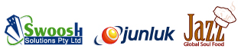
- Graphic logos uses a graphical illustration
clearly identifies what your business does.
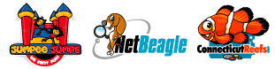
3. Wordmark Logos are the most popular and have very little or no graphical content. Wordmarks are essentially a typographical treatment of the brand, business or product name. 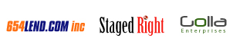
4. I am not sure - You decide.
Do you have any additional comments? *

Include additional design concepts

And

Links of the websites whose logo you like.

